The Anatomy of a Delay: Diagnosing Shipping Route Efficiency at Nassau Candy Distributor

Vipsa Patel
Data Analyst Intern, Unified Mentor

Abstract

This paper presents a descriptive and diagnostic analytics system designed to evaluate the efficiency of factory-to-customer shipping routes for Nassau Candy Distributor, a national specialty confections and fine foods distributor operating five factories. Using 10,194 orders placed between January 2024 and December 2025, the study first identifies and corrects a systematic date-encoding error in the raw shipment records and then engineers a composite Route Efficiency Score that weights shipping speed, consistency, and reliability. These metrics power an interactive Streamlit dashboard with five modules: a route efficiency leaderboard, a geographic flow map, a ship-mode comparison, a state-level drill-down, and an automated findings panel. Unlike predictive or prescriptive systems, this work deliberately remains descriptive: every figure reported is a direct, auditable computation over historical data, not a model forecast. The analysis finds that ship mode is a far stronger predictor of delay than customer geography (a 30.9-percentage-point spread across ship modes versus roughly 1 point across regions) and identifies New Mexico as a specific geographic bottleneck (56.8% delay rate) and shows that faster shipping is not reserved for higher-value orders in the dataset. These findings translate directly into targeted, low-risk operational recommendations.

1. Introduction

Nassau Candy Distributor is a specialty confections and fine foods distributor that ships chocolate, sugar, and other confectionery products from five factories to customers across the United States and, to a much smaller extent, Canada. Historically, shipping performance has been understood only anecdotally: staff know that some routes “feel” slower than others, but no systematic, route-level view exists of which factory-to-customer combinations are efficient, which regions or states experience disproportionate delay, or whether the choice of shipping method is being used effectively. Without this visibility, any operational response to a slow route is guesswork rather than evidence.

This paper documents the construction of a descriptive analytics system intended to close that gap. The scope of the work is deliberately diagnostic rather than predictive: the goal is to quantify what has already happened—which routes are fast, which are slow, where delays cluster, and whether shipping method or geography better explains the variation—using transparent, auditable arithmetic rather than a trained model. This distinction matters operationally: every number in the resulting dashboard can be traced back to a simple aggregation over real orders, which makes the findings easy for non-technical stakeholders to trust and to challenge.

The contributions of this work are (1) identification and correction of a systematic data-quality issue in the raw shipment dates, validated against domain logic rather than discarded; (2) a composite route Efficiency Score that blends speed, consistency, and reliability into a single 0-100 metric, computed live over whatever subsets of data a user filters to; (3) a small-sample safeguard that excludes low-volume routes from headline rankings; and (4) an interactive dashboard, built in Streamlit, that makes all of the above explorable by non-technical stakeholders.

2. Related Work

Supply chain performance measurement has a long history in operations management. Chopra and Meindl (2016) provide the standard strategic framework for understanding the drivers of supply chain performance, including transportation and the trade-offs between shipping speed and cost. In the last-mile delivery literature specifically, Janjevic, Winkenbach, and Merchan (2019) discuss how delivery network design decisions interact with service-level outcomes, underscoring that geographic and operational factors both contribute to delivery performance—a tension this paper examines empirically for Nassau Candy.

Methodologically, this work follows the exploratory data analysis tradition established by Tukey (1977): before any scoring framework was designed, the underlying distributions of lead time, delay rate, and order value were inspected directly, which is how the data-encoding defect described in Section 3 was first noticed. The broader motivation for building an interactive, self-service analytics tool rather than a static report follows Davenport and Harris (2007), who argue that competitive advantage increasingly comes from making analytics directly accessible to operational decision-makers rather than confining it to specialist teams.

This paper does not attempt predictive lead-time modeling or prescriptive factory reallocation, both of which are active areas of supply-chain analytics research. Those approaches require a validated training pipeline and carry the risk of opaque recommendations; the approach here instead prioritizes a fully transparent, descriptive baseline that a small internal team can maintain and that stakeholders can audit line by line.

3. Dataset and Data Preparation

3.1 Dataset Schema
The analysis uses Nassau Candy’s order-level shipment records, containing 10,194 rows spanning January 2024 through December 2025. Each row includes Row ID, Order ID, Order Date, Ship Date, Ship Mode, Customer ID, Country/Region, City, State/Province, Postal Code, Division, Region, Product ID, Product Name, Sales, Units, Gross Profit, and Cost. Products map to one of five factories (Lot’s O’ Nuts, Wicked Choccy’s, Sugar Shack, Secret Factory, and The Other Factory) via a fixed division-level assignment table supplied separately from the order data.

3.2 Data Quality: The Ship-Date Encoding Defect
Initial exploration of the raw lead time (Ship Date minus Order Date) revealed an implausible distribution: values ranged from roughly 900 to over 1,600 days, with Order Date years concentrated in 2024-2025 but Ship Date years spanning 2026-2030. No candy shipment plausibly takes multiple years to arrive, so this was diagnosed as a systematic multi-year offset introduced somewhere upstream of the extract, rather than a small number of bad rows. Rather than discarding the Ship Date field—which would have removed the only available measure of shipping performance—the underlying short-cycle signal was recovered using modular arithmetic: the raw difference in days was reduced modulo 30, on the reasoning that the corrupting offset was a whole number of higher-order time units layered on top of an intact day-of-month cycle.

The correction was validated, not assumed: the corrected lead times were cross-tabulated against Ship Mode, and the resulting averages increased monotonically from Same Day (10.3 days) to First Class (12.5 days) to Second Class (13.3 days) to Standard Class (14.9 days)—exactly the ordering a shipping method hierarchy should produce. This internal consistency check is the basis for treating the corrected field as a real signal rather than an artifact of the repair.

3.3 Geographic and Categorical Standardization
City, state/province, country, and region text fields were trimmed and title-cased for consistent grouping. A lookup table of latitude/longitude centroids was built for all 59 state/province values present in the data (51 U.S. states and territories plus the District of Columbia and 10 Canadian provinces), since no such coordinates existed in the source data. The five factories were geocoded individually. Customers are grouped into four custom shipping regions—Atlantic, Gulf, Interior, and Pacific—defined by Nassau Candy rather than U.S. Census regions, and centroid coordinates for each region were computed as the mean location of its constituent states for use in the geographic flow visualization described in Section 5.

4. Methodology

4.1 The Route Efficiency Score
A route is defined as a Factory→State/Province pair. For every route (or, depending on the view, every Factory→ Region or state-level aggregate), three component metrics are computed from the underlying shipments:
- Speed—the average shipping lead time, in days.
- Consistency—the standard deviation of lead time, capturing how predictable a route is, independent of how fast it is on average.
- Reliability—the delay rate, i.e., the share of shipments exceeding a configurable delay threshold.

Each component is min-max scaled to a 0-100 range across the current comparison set and inverted so that higher is always better (a lower average lead time yields a higher speed score, and so on). The three scores are then combined as a weighted composite:

Efficiency Score = 0.5* Speed + 0.3* Consistency + 0.2* Reliability
Speed is weighted most heavily because lead time is the metric most directly visible to the end customer. Consistency is weighted above reliability because a route that is unpredictable erodes trust even when it is rarely severely late. Critically, because the min-max scaling is performed over whatever subset of data is currently selected, the Efficiency Score is always relative to the active comparison group—a route’s score can change if the user narrows the filter to a single region or date range, since the field of comparison changes. This is a deliberate design choice appropriate for an interactive exploration tool and is discussed further as a limitation in Section 8.

4.2 Small-Sample Protection
Of the 196 unique factory-state routes present in the full dataset, many have very low shipment counts; the single most "efficient" route by raw score, before any safeguard, had exactly one shipment. A route is analogous to a sports team: it should not be ranked first in the league after playing a single game. To prevent this, routes require a minimum of 5 shipments to appear in the Route Efficiency Leaderboard, and states or factories require a minimum of 30 shipments to be eligible for the automated bottleneck and comparison findings described in Section 5. Lower-volume routes are not hidden from the application—they remain visible in the state-level drill-down—but they are excluded from headline rankings where a small sample could otherwise produce a misleading extreme value.

4.3 Delay Threshold
A shipment is flagged as delayed if its corrected lead time exceeds a threshold, defaulted to 18 days (approximately the 75th percentile of the overall lead time distribution, which ranges from 4 to 22 days after correction). This threshold is exposed as a slider in the dashboard rather than fixed in code, so every delay-rate figure throughout the application—including the automated findings—recomputes live against whatever threshold the user selects.

5. Dashboard Architecture

The methodology above is implemented as an interactive Streamlit web application, styled around Nassau Candy’s existing brand identity (cream background, espresso and gold accent colors, and serif headings) rather than a generic business intelligence theme. The application is organized into a persistent filter bar and five content modules, described below with representative screenshots.
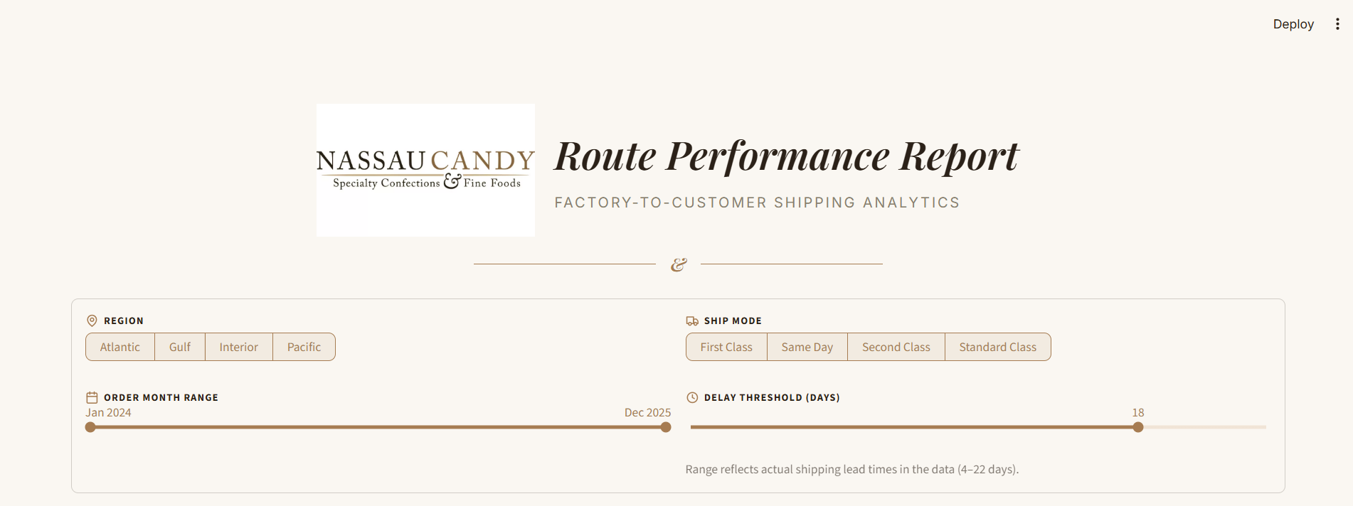
Figure 1: Report masthead and filter bar. Region, Ship Mode, Order Month, and Delay Threshold filters apply globally across all five modules below.

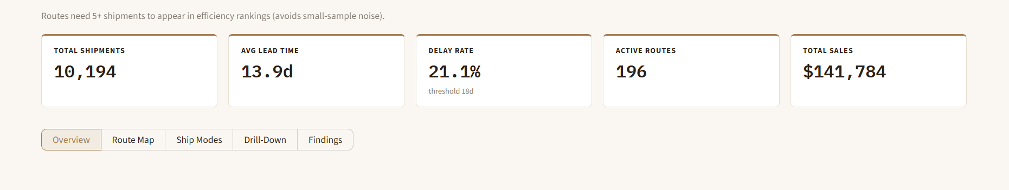
Figure 2: Top-level KPI row (recomputed live from the active filter selection) and the pill-style section navigator.

5.1 Module 1: Route Efficiency Overview
The overview module renders the Route Efficiency Leaderboard: horizontal bar charts of the top 10 and bottom 10 qualifying routes (5+ shipments), sharing a common 0-100 x-axis so that the bar length is directly comparable between the two charts, colored on a consistent terracotta-to-sage scale.

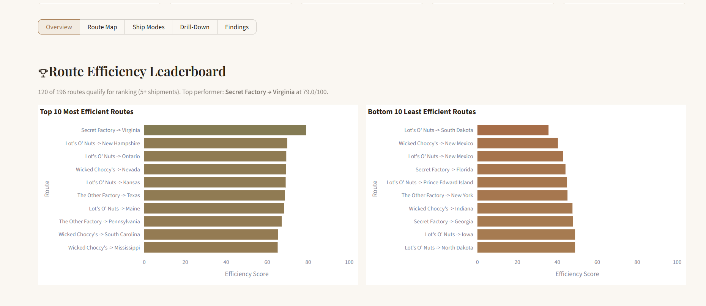
Figure 3: Route Efficiency Leaderboard. Top performer Secret Factory→Virginia scores 79.0/100; 120 of 196 routes qualify for ranking under the 5-shipment minimum.

5.2 Module 2: Geographic Flow Map
An earlier iteration of this module drew one arc per factory-state route (up to 120 simultaneous arcs), which proved visually cluttered and difficult to read. The final design aggregates to Factory→Region flows—at most 20 arcs across five factories and four regions—with arc thickness encoding shipment volume and arc color encoding the Efficiency Score. Full state-level detail is not discarded; it is made available in a secondary, collapsible choropleth beneath the map for users who want finer granularity.
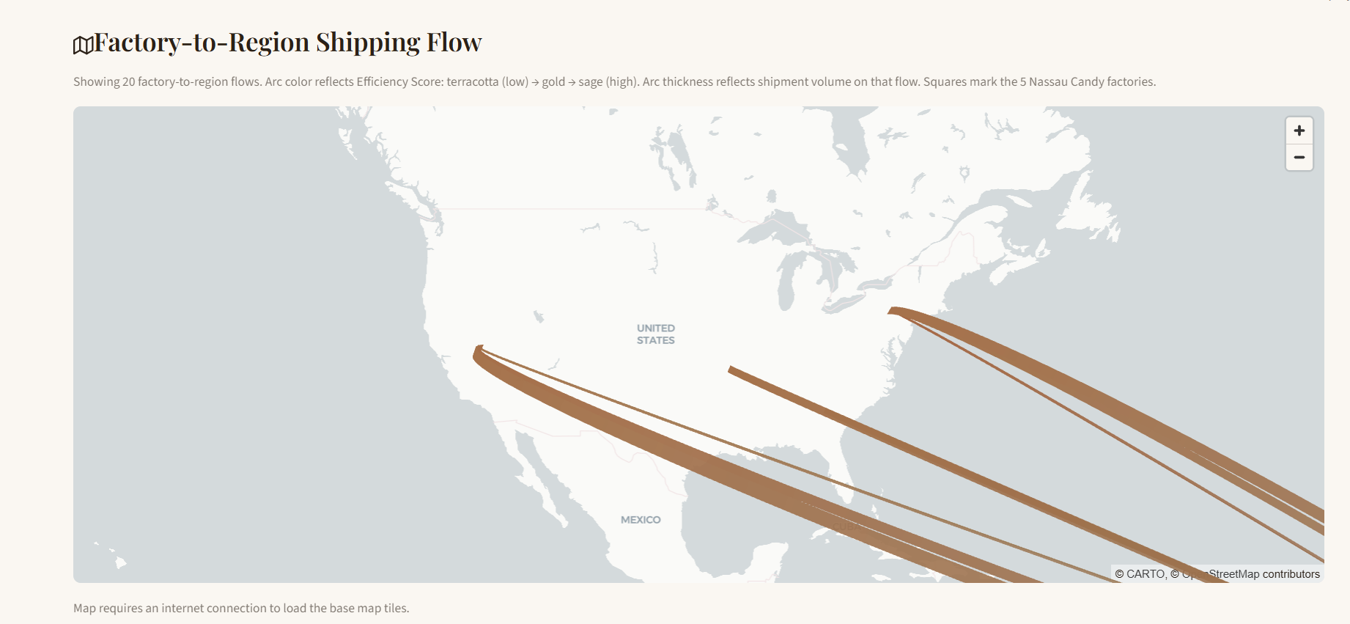
Figure 4: Primary geographic view: factory-to-region shipment flow. Squares mark the five factory locations.
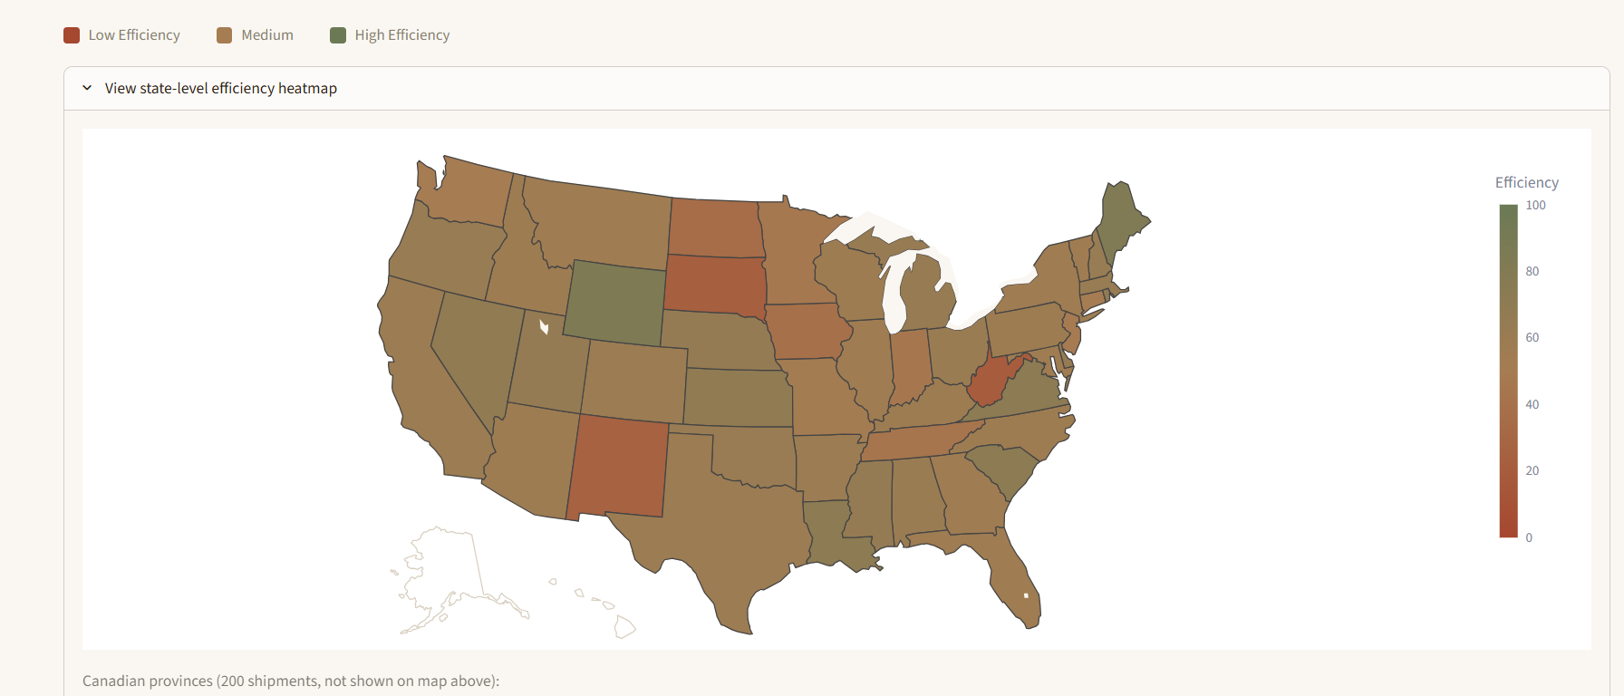
Figure 5: Secondary, expandable state-level efficiency heatmap covering all 51 U.S. states and territories in the data.
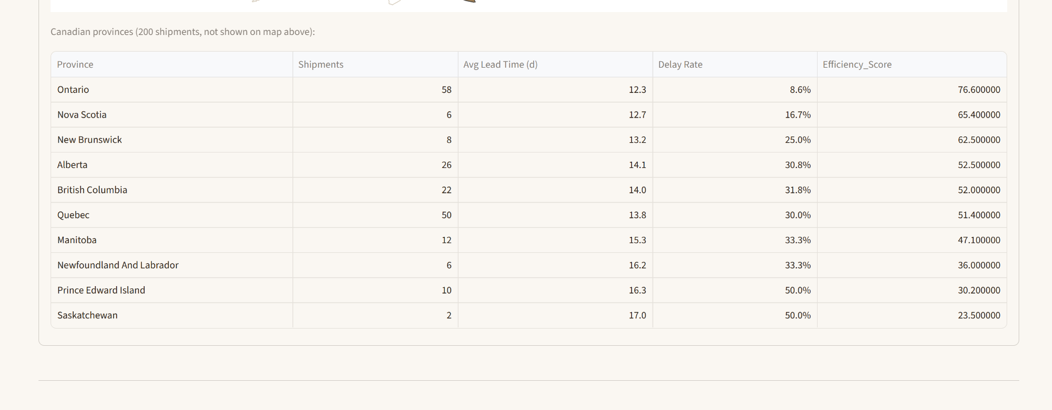
Figure 6: Canadian provinces (approximately 2% of total shipment volume) are reported in a separate table rather than forced onto a U.S.-only choropleth.
5.3 Module 3: Ship Mode Comparison
This module compares the four shipping methods—Same Day, First Class, Second Class, and Standard Class—on average lead time and on the full lead time distribution (via box plot, which reveals variability that an average alone would hide).

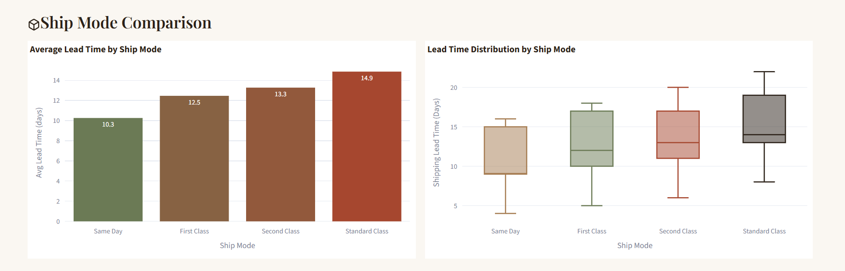
Figure 7: Average lead time (left) and lead time distribution (right) by ship mode.

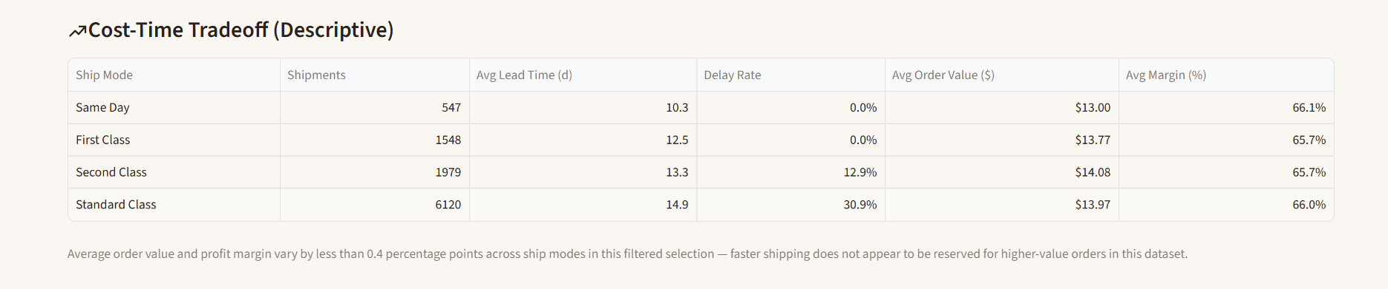
Figure 8: Cost-Time Tradeoff Table: Shipment volume, delay rate, average order value, and average margin by ship mode.

5.4 Module 4: Route Drill-Down
Users select any state or province to see its shipment volume, average lead time, delay rate, and Efficiency Score (with its rank among all currently-filtered locations), a breakdown of which factories serve that state, and a monthly trend view. An earlier version of this module plotted every individual shipment as a point on a scatter plot; for a high-volume state, this produced several thousand overlapping, hard-to-read points. The final design instead aggregates to a monthly average lead time line chart and a monthly shipment volume bar chart—a more standard, immediately legible chart format.
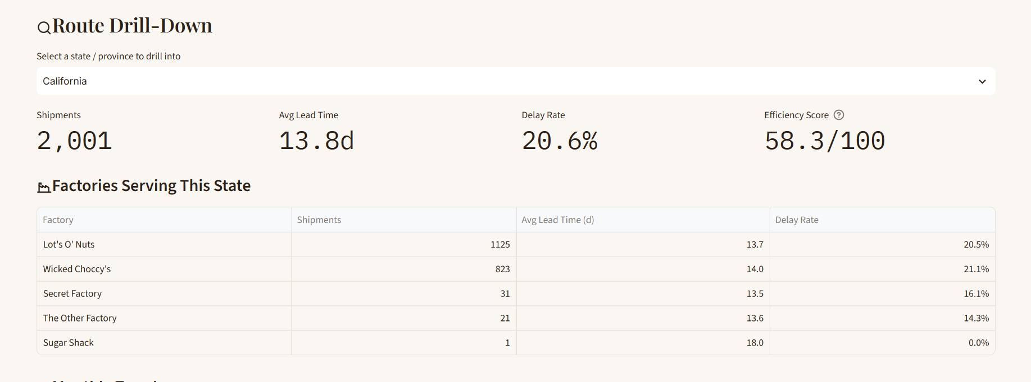
Figure 9: State-level drill-down for California: KPI summary and per-factory breakdown.

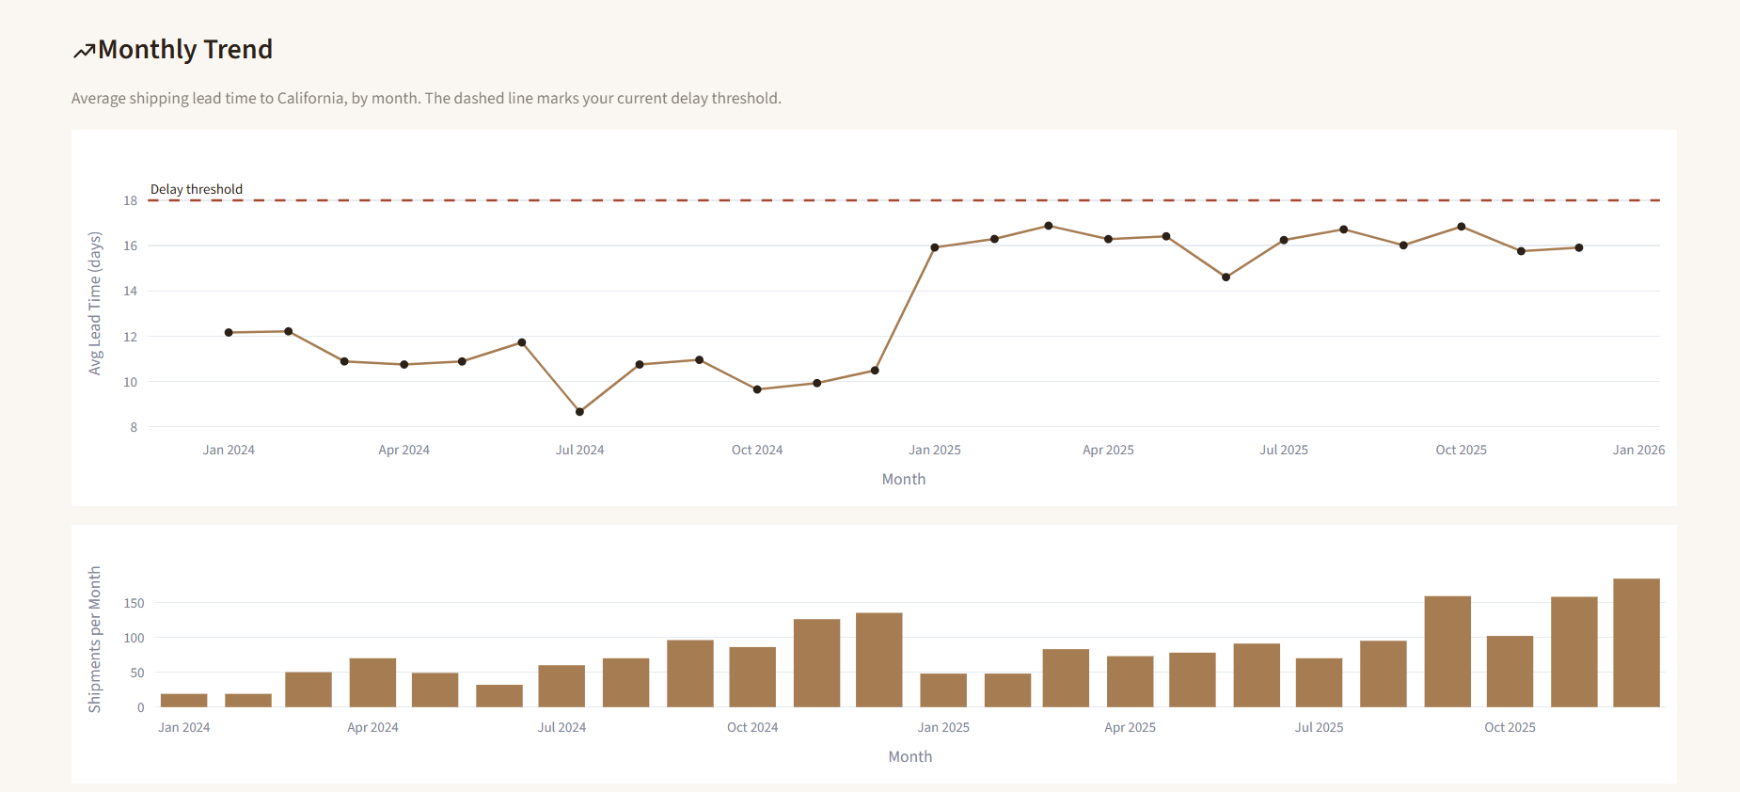
Figure 10: Monthly average lead time and shipment volume trend for California. Average lead time rises from roughly 10-12 days in 2024 to 15-17 days in 2025.

5.5 Module 5: Automated Key Findings
The final module generates plain-language findings directly from whatever data is currently filtered, rather than from a fixed hardcoded list. Each finding is computed from a specific comparison (e.g., the spread in delay rate between the best- and worst-performing ship modes) and is only surfaced if that comparison exceeds a materiality threshold so that the panel does not manufacture a finding out of noise when the underlying difference is small. Findings are tagged "Risk," "Context," or "Strength" and rendered as color-coded cards.

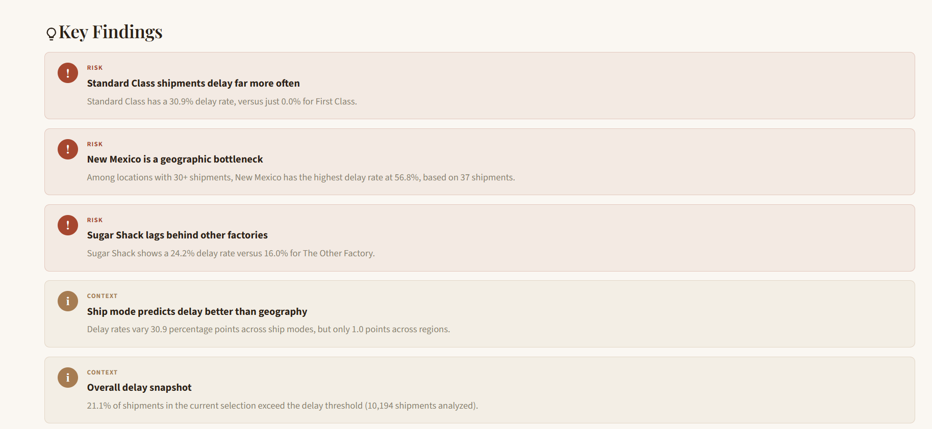
Figure 11: Automated Key Findings panel, part 1 of 2.

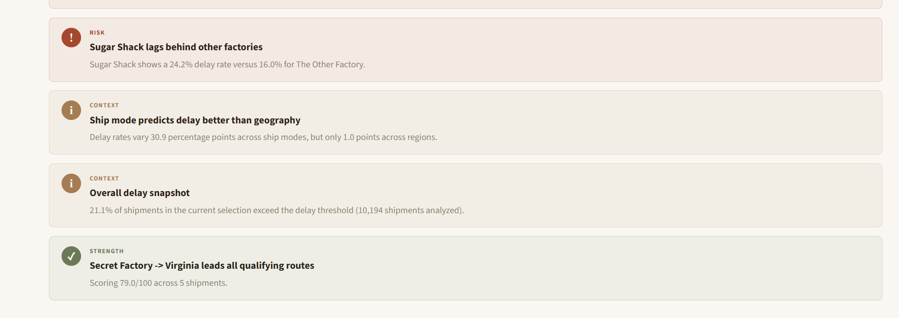
Figure 12: Automated Key Findings panel, part 2 of 2.

6. Results

Across the full dataset of 10,194 shipments (default 18-day delay threshold, all regions and ship modes included), the system surfaces the following findings:

- 196 unique factory-state routes exist; 120 meet the 5-shipment minimum for leaderboard ranking.
- The top-ranked qualifying route is Secret Factory→Virginia, at 79.0/100.
- Ship Mode is the strongest driver of delay identified in this dataset: Standard Class has a 30.9% delay rate versus 0.0% for First Class and Same Day—a 30.9 percentage-point spread, compared with roughly 1 percentage point of spread across the four customer regions.
- New Mexico is a specific geographic bottleneck: among states with 30+ shipments, it has the highest delay rate at 56.8%.
- Sugar Shack shows a 24.2% delay rate versus 16.0% for The Other Factory, though Sugar Shack’s much smaller shipment volume means this comparison should be treated directionally rather than conclusively.
- Average order value and profit margin vary by less than half a percentage point across ship modes—faster shipping is not being reserved for higher-value orders in this dataset, which rules out one otherwise plausible explanation for the Standard Class delay pattern (i.e., that low-value orders are deliberately deprioritized).

The California case study illustrated in the drill-down module (Figure 10) shows the average lead time rising from approximately 10-12 days across 2024 to a sustained 15-17 days through 2025, alongside increasing shipment volume—a pattern consistent with a high-volume state’s service level degrading as demand grew, though the causal driver cannot be determined from this descriptive analysis alone.

7. Discussion

The most operationally significant result is the relative size of the ship-mode effect compared with the geographic effect. If the customer region explained most of the variation in delay, the natural response would be to open a new factory or redraw the regional map. Instead, the data show that which shipping method is selected for an order predicts delay far better than where the order is going. This points toward carrier service-level agreements, internal handling prioritization, or Standard Class-specific process bottlenecks as more promising areas for operational investigation than geographic network redesign.

The absence of a cost-time tradeoff (Section 6) is itself informative: it rules out the hypothesis that Standard Class delays are simply a byproduct of that tier being used for lower-value orders that receive less operational attention. Average order value is statistically flat across all four ship modes, so whatever is driving Standard Class’s elevated delay rate is a property of the shipping tier itself, not of the orders assigned to it.

The small-sample threshold (Section 4.2) trades completeness for statistical honesty. This means the Route Efficiency Leaderboard, by design, cannot speak to the 76 lowest-volume routes at all—a deliberate omission rather than an oversight, and one that should be stated explicitly whenever the leaderboard is presented to stakeholders.

8. Limitations and Future Work

- Descriptive, not predictive: this system reports what has already happened; it does not forecast future lead times or simulate the effect of a hypothetical factory reallocation. A predictive layer is a natural, separately scoped extension once more historical data accumulates.
- Score relativity: Because the Efficiency Score is min-max scaled within the current filter selection, a route’s score is only meaningful relative to the comparison group active at the time it is viewed and is not a fixed, portable rating.
- Geographic approximation: state and region centroids approximate customer location for mapping purposes; the true delivery point can differ meaningfully from a state’s geographic center, particularly for large states such as California or Texas.
- Margin as a proxy: no explicit per-shipment carrier cost field exists in the source data, so the Cost-Time Tradeoff table uses product Gross Profit and Sales as a proxy for order economics rather than true shipping cost-to-serve.
- Small Canadian volume: Canadian provinces account for approximately 2% of shipments and are reported in a separate table rather than a full choropleth; conclusions about Canadian performance should be treated as preliminary given the limited sample.

Future work could extend the drill-down module to the route level (rather than the state level) for monthly trends and incorporate a true shipping-cost field if one becomes available from carrier billing data and, as a clearly separated v2 initiative, introduce a lightweight predictive layer once sufficient historical volume exists to validate it—while preserving this descriptive baseline as an audit trail against which any future model’s outputs could be checked.

9. Conclusion

This paper presented a descriptive analytics system for factory-to-customer shipping route efficiency at Nassau Candy Distributor, built around a corrected and validated shipment-date field, a composite Route Efficiency Score, and an interactive five-module Streamlit dashboard. Rather than a predictive or prescriptive model, the system prioritizes transparent, auditable metrics that non-technical stakeholders can trust and interrogate directly. The analysis identifies ship mode, not geography, as the dominant driver of shipment delay; flags New Mexico as a specific bottleneck worth investigating; and rules out order value as an explanation for the Standard Class delay pattern—three concrete, evidence-based starting points for Nassau Candy’s logistics team.

10. References

Chopra, S., & Meindl, P. (2016). Supply chain management: Strategy, planning, and operation (6th ed.). Pearson Education.

Davenport, T. H., & Harris, J. G. (2007). Competing on Analytics: The new science of winning. Harvard Business School Press.
Janjevic, M., Winkenbach, M., & Merchan, D. (2019). Integrating collection-and-delivery points in the strategic design of urban last-mile e-commerce distribution networks.
Transportation Research Part E: Logistics and Transportation Review, 131, 37-67.
https://doi.org/10.1016/j.tre.2019.09.001

Tukey, J. W. (1977). Exploratory data analysis. Addison-Wesley.

Acknowledgement
I thank Unified Mentor for providing access to the Nassau Candy dataset and for supporting this research paper as part of the Data Analyst Internship program.

